# Diabetes App Research Project Website

# Quick User Guide

Note: Please use Google Chrome or Internet Explorer/Edge. Some functions will not work with Firefox. Safari, Opera, and other browsers have not been tested.

## Deploying & Hosting

The webpage is hosted on Google Firebase using Node.JS and the Firebase SDK.

If Node.js and the Firebase SDK are not already installed skip ahead to First Time Install. Otherwise, the following commands will deploy the website to the host and disable hosting.

### Hosting

From the directory /Team_26_capstone_2017/diabetesarpweb/ run the command

* firebase deploy

The website will upload in a few minutes.

In your web browser navigate to <https://diabetesarp.firebaseapp.com> to confirm that the website is available.

Additionally, check the Hosting tab in the Firebase Console to view the status of the website.

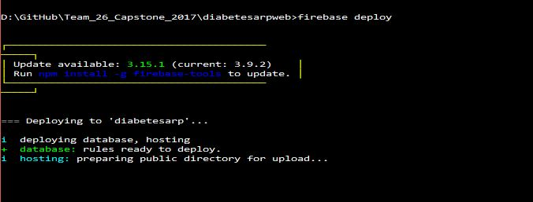

### Disabling Hosting

From the directory /Team_26_capstone_2017/diabetesarpweb/ run the command

* firebase hosting:disable

In your web browser navigate to <https://diabetesarp.firebaseapp.com> to confirm that the website is available.

Additionally, check the Hosting tab in the Firebase Console to view the status of the website.

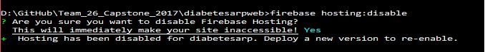

## First Time Install

Download Node.js version 8.9.1 LTS from <https://nodejs.org> and install.

Open the Node.js Command Line (PC) or Node.js Terminal Window (Mac) and navigate to the project directory (in this case /Team_26_capstone_2017/diabetesarpweb)

Install the Firebase CLI with the node packet manager

* npm install -g firebase-tools

After installation completes Login to your Firebase account with the command

* firebase login

The login process will be completed in a browser window.

Refer to the earlier sections on Hosting from this point.

## Website Functions

### Browsers

Please use Internet Explorer/Edge or Google Chrome to access the website.

Note: In IE/Edge the Login page date picker displays a US format placeholder, mm/dd/yyyy rather that the standard international format but the date picker will correctly insert the string into the Firebase Auth password field as yyyy-MM-dd.

### Creating users and Logging In

At the Login screen users should choose a username and insert their date of birth. The username is automatically appended with @diabetesarp.com. Hit Next after successfully creating a new user or logging in.

Note: Use the date picker in IE/Edge

### User Details

Insert Name, Phone Number, Date of Birth, and HbA1C reading.

### DKT Questions

23 questions. Multiple submissions are recorded in the database tagged with unix time.

### PedsQL Questions

5 sets of questions. Multiple submissions are recorded in the database tagged with unix time.

### Webpage Structure

* Index
  + Landing Page
    - User Details
    - DKT
    - PedsQL

## Useful Links

Node.js Firebase-Tools - <https://www.npmjs.com/package/firebase-tools>

Firebase Hosting Documentation - <https://firebase.google.com/docs/hosting/quickstart>